
Emil Reimann
Dresdner Stollen 750ｇ(in red box)
Emil Reiann
Premium Stollen 750ｇ(in black tin)
Doitsu Center
2023
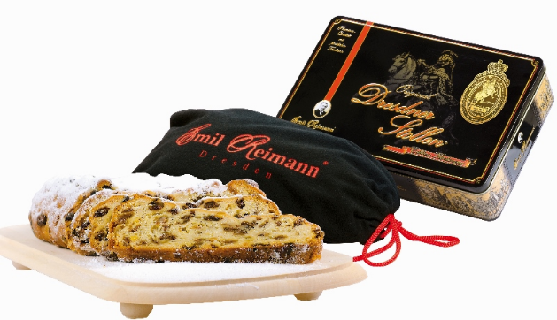
ChristmasCatalogueクリスマスカタログ

A highly popular size for gift giving. Please enjoy the authentic stollen that harmoniously blends the flavours of dried fruits like raisins and orange peel with almonds, for a moist and delicious treat.
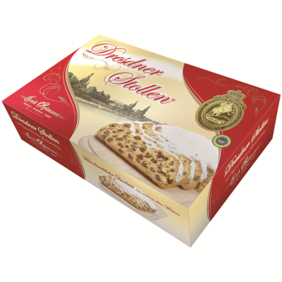
‘Premium Stollen’ is a traditional German fruitcake, made with carefully selected roasted almonds, bourbon vanilla, high
quality butter, brandy-soaked raisins, and more.
The Stollen dough is meticulously
shaped by hand. The Stollen is wrapped in a special cloth bag and presented in an elegant black tin, inspired by the wall paintings of
Dresden Castle. It also comes with powdered sugar.

The most popular stollen in Germany, Emil Reimann Dresdner Stollen, is coming to the UK!
Enjoy the authentic German Christmas cake.
Emil Reimann's Dresden Stollen has received the top award rating in the Stollen Test conducted by the German Product Testing Foundation in both 2005 and 2015.
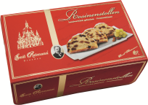
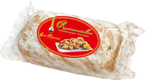

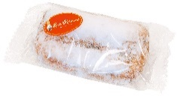
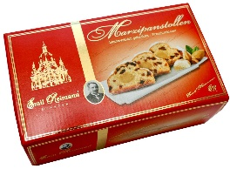

Your order will be accepted from the １０th November 2023 via email, phone, or the 'Contact' tab on the website.

The delivery of the products is scheduled to begin from the1st December 2023.

A classic stollen with a delightful blend of dried fruits and easy-to-enjoy marzipan. Perfect for 3-4 people.
Item No. | 59498
Price | ￡48
Item Size | 280×142×70㎜

Emil Reimann
Mini Stollen 250ｇ(in box・in foil)
Recommended for those who wish to enjoy a small quantity. Perfect for 3-4 people to finish in one go.Also,popular as a gift! Available in both box and bag types.
Item No. | 25481 | 25480
Price | （box）￡15 | （foil）￡13
Item Size | 150×90×55㎜

https://uk.doitsucenter.com
Email : info@doitsucenter.com
TEL : 44-7562999190
Doitsu Center Ltd., UK Branch
21 Ormond House Medway Street London SW1P 2TB
Doitsu Center Ltd.,2-4-39-4F-19 Toyo Koto-ku,Tokyo

Item No. | 59350
Price | ￡6
Item Size | 90×50×30㎜

This is also a product recommended for those who have never tried stollen before, in a palm sized portion.
Emil Reimann
Putit Stollen 80ｇ(in foil)
Item No. | 25484
Price | ￡15
Item Size | 150×90×55㎜

Emil Reimann
Marzipan Stollen 250ｇ(in box)
Item No. | 58402
Price | ￡30
Item Size | 285×146×70㎜

„Golden Stollen Knight“
award
The embossed of "Golden Stollen Knight" is awarded annually by the Dresden Stollen Protection Association.
• The displayed prices are all inclusive of taxes. • Actual products and package designs may differ.

